Analysing Product Sentiment (QUIZ:1)

1.Question:1
The simple threshold classifier for sentiment analysis described in the video (check all that apply):
Ans:1 Must either count attributes equally or pre-define weights on attributes.
2: Must have pre-defined positive and negative attributes.

2.Question:2

For a linear classifier classifying between “positive” and “negative” sentiment in a review x, Score(x) = 0 implies (check all that apply):

Ans: We are uncertain whether the review is “positive” or “negative”.

3.Question :3

For which of the following datasets would a linear classifier perform perfectly?

Ans:
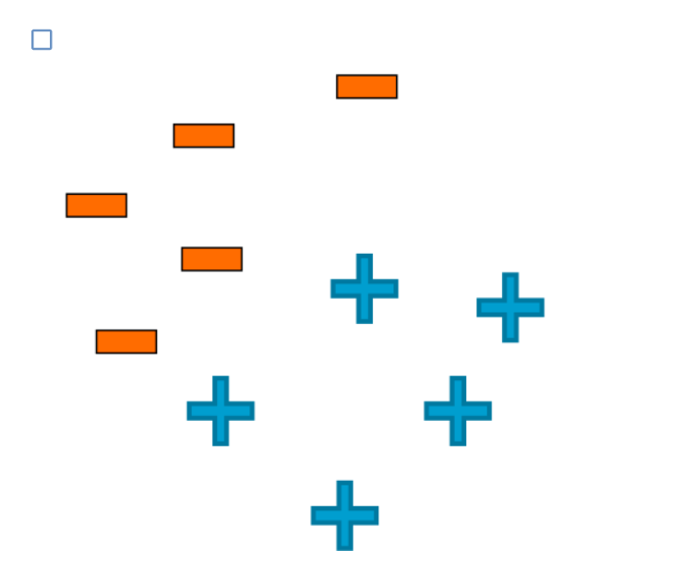

4.Question:4

True or false:

High classification accuracy always indicates a good classifier.

Ans: False

5.Question:5

True or false:

For a classifier classifying between 5 classes, there always exists a classifier with accuracy greater than 0.18.

Ans: True

6.Question:6

True or false:

A false negative is always worse than a false positive.

Ans: False

7.Question:7

Which of the following statements are true? (Check all that apply)

Ans: test error tends to decrease with more training data until appoint, and then does not change(i.e., curve flattens out)

